 | KENYATTA UNIVERSITY  WOMEN’S ECONOMIC EMPOWERMENT HUB | 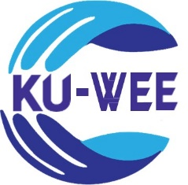

REPORT OF THE WOMEN IN MANUFACTURING VALIDATION WORKSHOP HELD ON 29TH AUGUST 2024 AT THE SENTRIM CASTLE ROYAL HOTEL, MOMBASA.

REPORT OF THE WOMEN IN MANUFACTURING VALIDATION WORKSHOP HELD ON 29TH AUGUST 2024 AT THE SENTRIM CASTLE ROYAL HOTEL, MOMBASA.
- Introduction
Women are key drivers of informal sector growth in Kenyan economy. Women enterprises constitute 20 percent of Kenyan Gross Domestic Product (GDP). Despite being critical contributors to the economy, they are underrepresented in the manufacturing sector. The 2018 Kenya Association of manufacturers (KAM) report indicate that only 17 percent are represented in the sector. As a result, KAM launched Women in Manufacturing (WIM) program in 2017 to address the underrepresentation. The program is based on four domains including networking and mentorship; market linkages; advocacy; and entrepreneurial development. It is unclear to what extent the WIM program has increased the proportion of women in manufacturing sector. Therefore, the study was conducted in Kiambu, Nairobi, Kisumu and Kakamega County to establish effectiveness of WIM program in promoting participation of women in manufacturing sector.
1.1 Workshop Objectives
The objective of the workshop was to present and validate the findings of the study undertaken. The workshop covered the following areas:
- KU-WEE Hub Overview and workshop Objective(s)
- Overview of WIM Study
- Methodology and Findings
- Policy Implications
- Question &Answer Session
- Sharing of Experiences as Women Manufacturers
1.2 Expected Outcomes
- Presentation and Validation of Findings: The findings are presented to workshop participants for review and validation. The participants are given the opportunity to provide feedback, ensuring that the results accurately reflect the experiences and perspectives of the respondents.
- Identification of Improvement Areas: The findings highlight key areas requiring improvement. The inputs from the relevant stakeholders are needed to help implement targeted actions aimed at enhancing the engagement of women in the manufacturing sector.
- Actionable Recommendations: The workshop discussions and outcomes contribute to the formulation of actionable recommendations, which are crucial for promoting the empowerment of women within the manufacturing sector. These recommendations direct efforts to address challenges and create opportunities for greater inclusion and participation of women.
1.3 Methodology
The workshop validation methodology involved respondents from Mombasa County who participated in the study. The workshop began with welcoming remarks, introduction of participants and KU WEE Hub, followed by overview of WIM Study. Discussions of findings with participants who provided feedback and additional insights was documented. The workshop concluded with a summary of the validated outcomes and feedback was incorporated into the final report for further action.
2. Workshop Proceedings
The meeting commenced at 10:00 am with an opening prayer led by Faith Tsuma. Dr. Korir facilitated the introduction of each workshop participants. Over 15 individuals from various agencies attended the workshop.
Dr. Angelica Njuguna delivered the welcoming remarks and introduced the KU WEE Hub to the participants. She provided an overview of the funders- Bill and Melinda Gates Foundation, and partners, discussed ongoing studies, and outlined the purpose of the workshop.
The opening remarks was given by the keynote speaker, Caroline Kungu Deputy Director of Industries, State Department for Industry in the Ministry of Investments, Trade and Industry. The remarks underscored the vital role of industrialization in driving Kenya’s economic growth and development. She mentioned that partnerships between Kenyatta University, the Ministry of Investments, Trade and Industry, and the Bill and Melinda Gates Foundation have been instrumental in addressing challenges faced by women in manufacturing, including cultural barriers, limited resources, and inadequate business skills. These collaborations aim to review policies, enhance women’s participation in industrialization, and align efforts with the Bottom-Up Economic Transformation Agenda (BETA). The speaker highlighted the need for a robust manufacturing sector to create jobs, reduce inequalities, and empower women, who already make significant contributions to Kenya's economy.
The speech also detailed key government initiatives designed to support women in manufacturing. These include the establishment of County Aggregations and Industrial Parks (CAIPs), market linkages through trade fairs and exhibitions, entrepreneurship training, and advocacy programs. The speaker called on women to seize available opportunities and participate in programs such as the Kenya Industry and Entrepreneurship Project (KIEP) and ENABLE Youth Kenya. Closing with gratitude, the remarks recognized the contributions of stakeholders, women entrepreneurs, and manufacturers while officially opening the workshop aimed at fostering economic inclusion and empowering women in trade and manufacturing.
After a photo session and tea break, Faith Tsuma presented the overview of the WIM study to members present during the workshop. She highlighted the purpose of the study and noted that the study’s focus was on women engaged in the manufacturing sector (Kenya Association of Manufacturers (KAM) and Women in Manufacturing (WIM) members).
Thereafter, Dr. Angelica presented the methodology and findings. The objectives of the study are (i) to evaluate the effectiveness of WIM program in promoting women economic empowerment; and (ii) to evaluate its impact on women’s access and control over resources and decision making. The study used both quantitative and qualitative data. Survey and focus group discussion were used in obtaining information from the women selected for the study. Pretesting of the questionnaire was done in Kiambu County to ensure that the study met its objective. The actual survey was done in Nairobi, Mombaza and Nyanza
In terms of the first objective, the performance was measured in terms of an increase in profitability, a percentage change in sales, and a percentage change in turnover. The highlights of the empirical findings are:
- In general, for women-owned enterprises the variables namely age, total employment, square of employment, household size, business age, ethnicity, credit access, university education, types of business ownership have significant contributions to the performance of women-owned enterprises.
- Age, total employment, marital status, access to credit and university education all contributed to the improved performance of women-owned enterprises. On the other hand, empirical findings in this study showed that household size and ethnicity are likely to restrict business performance.
- The women’s businesses also follow a diminishing marginal return due to an increase in labor beyond its optimal size.
- Finally, the empirical results suggest that memberships to KAM and to WIM have contributed positively to the higher business performance of the women-owned enterprises. This could have been attributed to the mentoring, training, networking and other activities WIM has been providing to its members.
In terms of the second objective, women economic empowerment relates to access & control to productive assets including access to household assets; control of household earnings, control over large household purchases. On the other hand, the level of decision making within the household measured by decision on Investment; decision on savings and Credit, and decision on the use of productive resources. The results were derived using economic/econometric model and showed the following:
- Age, marital status, experience, education and household size determine the level of access to productive assets and control over earning and large purchases by women in the households.
- While age of women raises the likelihood of unilateral access and control over resources, the other attributes again limit them in handling the said resources. The findings show that married women are less likely to have complete access to household productive assets and economic resources.
- Neither being a member of WIM nor KAM change the cultural practices where married women have to ask permission with their spouses before they can have their hands on the common household economic resources.
In conclusion, the KAM and WIM program were instrumental in enhancing performance of women in manufacturing, although it did not equally improve women’s access and control over household resources.
Dr. Korir then presented the policy implications and recommendations to the various stakeholders from the study. He emphasized on the need of empowering women through increasing their profitability. He recommended on bringing on board all women in manufacturing to the WIM program due to its effectiveness. The program was vital in mentorship and coaching of its members in enhancing their performance in the manufacturing sector. The WIM Program needed to reduce its joining cost and tailor the program to address needs of Micro Small and Medium Enterprises (MSMEs) to encourage more women to join. Moreover, there was need of introducing revolving funds to help in running women businesses.
3. Recommendation And Interventions from Workshop Participants
The following was the recommendation received from a participant:
- Kenya Association of Manufacturers (KAM) should Micro and Small Enterprises Authority (MSEA) to their workshops.
Other interventions from the discussion include:
- Regulation is an obstacle for entrance into cottage industries.
- Women entrepreneurs face inadequate circulation of information from the Ministry of Industrialization, Trade and Industry and other stakeholders.
- Men should not be left behind- encouraging joint business ownership. This reaction was welcomed and responded to as follows: WIM study targeted women because of their less representation in the manufacturing sector.
4. Conclusions
The Women in Manufacturing (WIM) validation workshop effectively highlighted the critical role of women in Kenya’s economic growth and the need to address their underrepresentation in the manufacturing sector. The workshop validated findings from a study conducted in four counties, underscoring the significant impact of the WIM program in enhancing women’s performance through mentorship, training, and market linkages. However, challenges such as cultural norms, regulatory barriers, and limited access to information and resources remain significant. Key recommendations included reducing program costs, tailoring support to MSMEs, introducing revolving funds, and fostering joint business ownership. Participants emphasized the importance of collaboration among stakeholders to drive inclusive economic empowerment and create a more enabling environment for women manufacturers.
5. Closing Remarks and Vote of Thanks
Dr. Julius Korir delivered the closing remarks, expressing gratitude to all participants for their active involvement and contributions to the workshop. He acknowledged the valuable discussions and insights shared during the session. He then gave the final vote of thanks, appreciating everyone for their presence and efforts.
ANNEXES
ANNEXE 1: LIST OF PARTICIPANTS
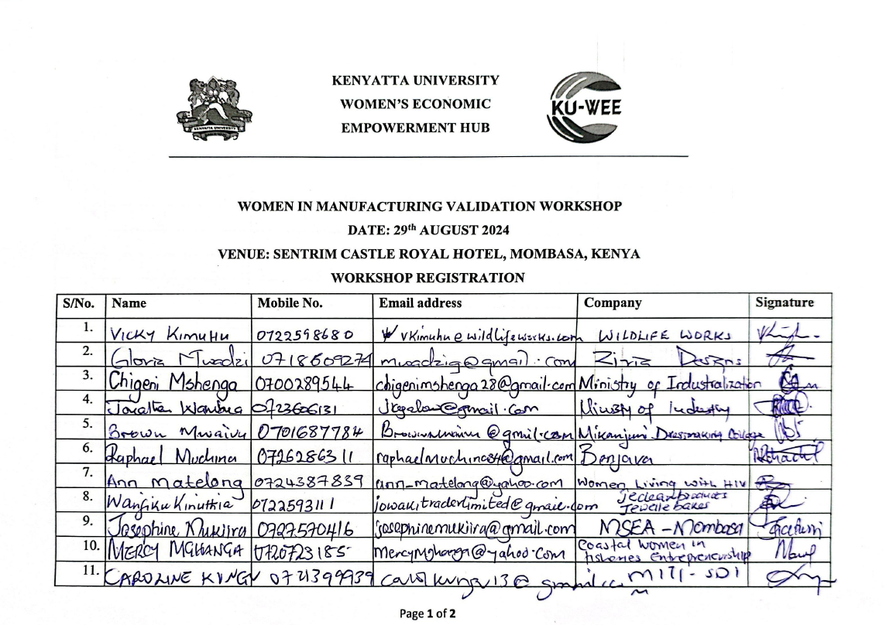
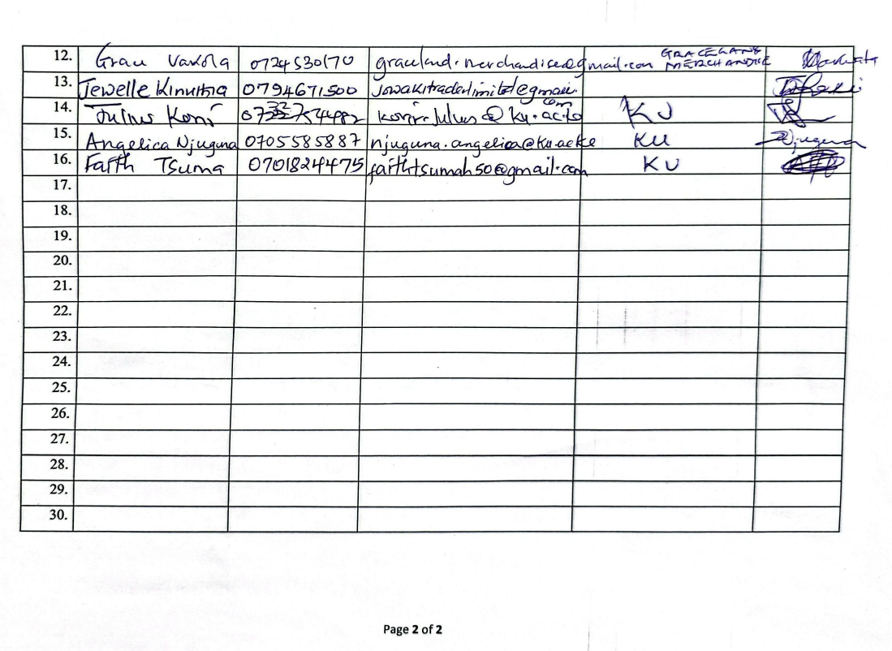
ANNEXE 2: WORKSHOP PROGRAMME

KENYATTA UNIVERSITY
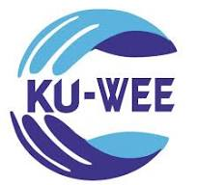

WOMEN’S ECONOMIC EMPOWERMENT
HUB

WOMEN-IN-MANUFACTURING (WIM) VALIDATION WORKSHOP
DATE: 29TH AUGUST 2024. TIME: 8.00 AM – 2.00 PM
VENUE: SENTRIM CASTLE ROYAL HOTEL, MOMBASA

Moderator: Dr Julius Korir
TIME | ACTIVITY | PRESENTER
8.00 – 9.00 am | Arrival and Registration | Secretariat (Ms Faith Tsuma)
9.00 – 9.05 am | Opening Prayer | Ms Faith Tsuma
9.05 – 9.10 am | Introduction | Dr Julius Korir
9.10 – 9.30 am | Welcome Remarks, KU-Wee Hub  Overview and Workshop Objectives | Dr Angelica Njuguna  Co-Principal Investigator, WIM
9.30 – 9.45 am | Opening Remarks by the Chief Guest | Ms Caroline Kungu  Deputy Director, Ministry of Investment, Trade & Industry
9.45 – 10.00 am | Photo Session
10.00 – 10.30 am | Health Break
10.30 – 10.45 am | Overview of WIM Study | Ms Faith Tsuma
10.45 – 11.25 am | Methodology and Findings | Dr Angelica Njuguna
11.25 – 11.45 am | Policy Implications | Dr Julius Korir
11.45 am – 12.05 pm | Q & A Session | Dr Julius Korir
12.05 – 12.40 pm | Sharing of Experiences as Women Manufacturers | All Participants
12.40 – 12.45 pm | Closing Remarks and Vote of Thanks | Dr Julius Korir
12.45 – 2.00 pm | Lunch Break, Guests Leave

ANNEXE 3: PICTORIAL
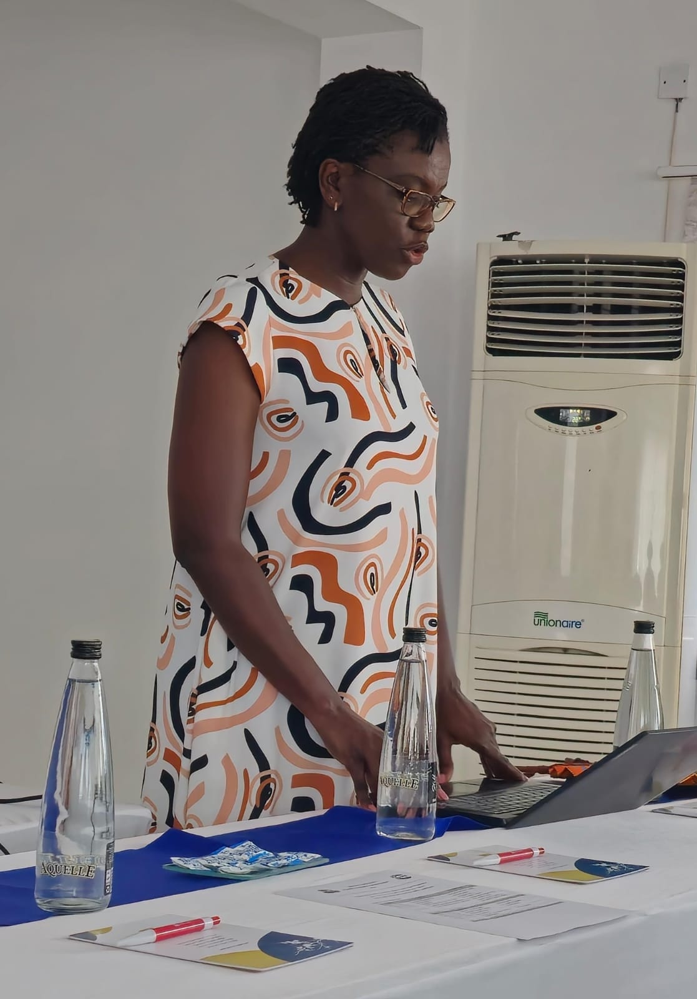

Picture 1: Deputy Director Caroline Kungu giving the opening remarks.

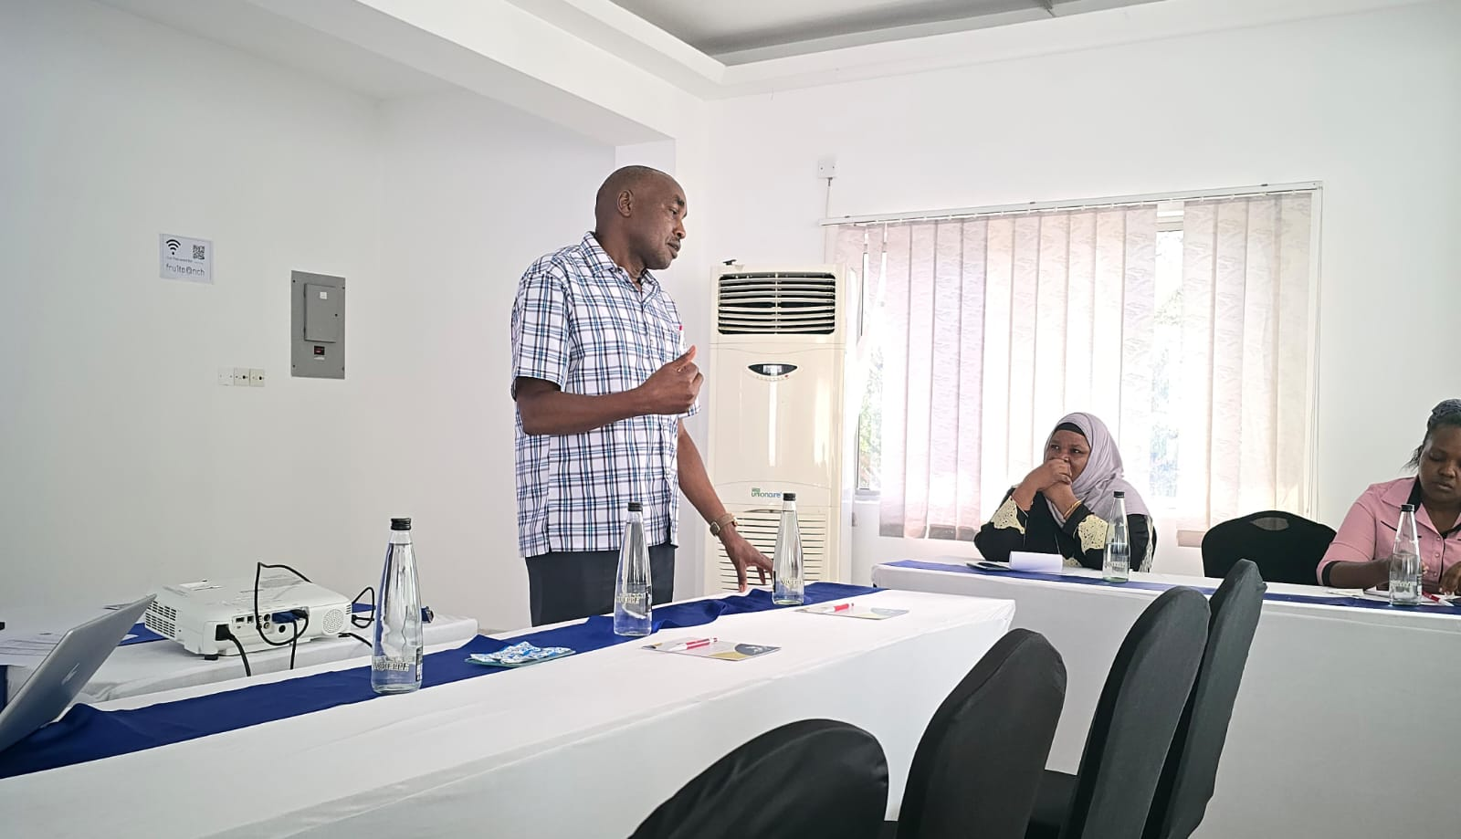
Picture 2: Dr. Julius Korir during his presentation.

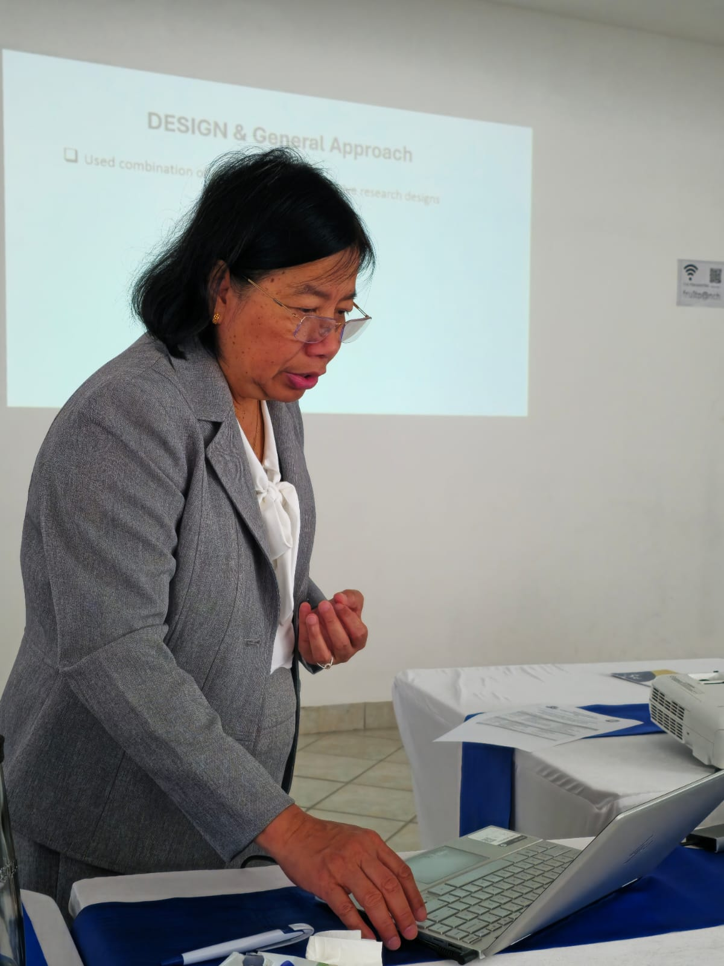

Picture 3: Dr. Angelica Njuguna during her presentation
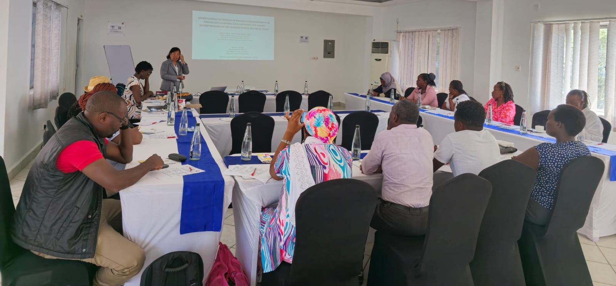
Picture 4: Workshop Participants, validation meeting in progress

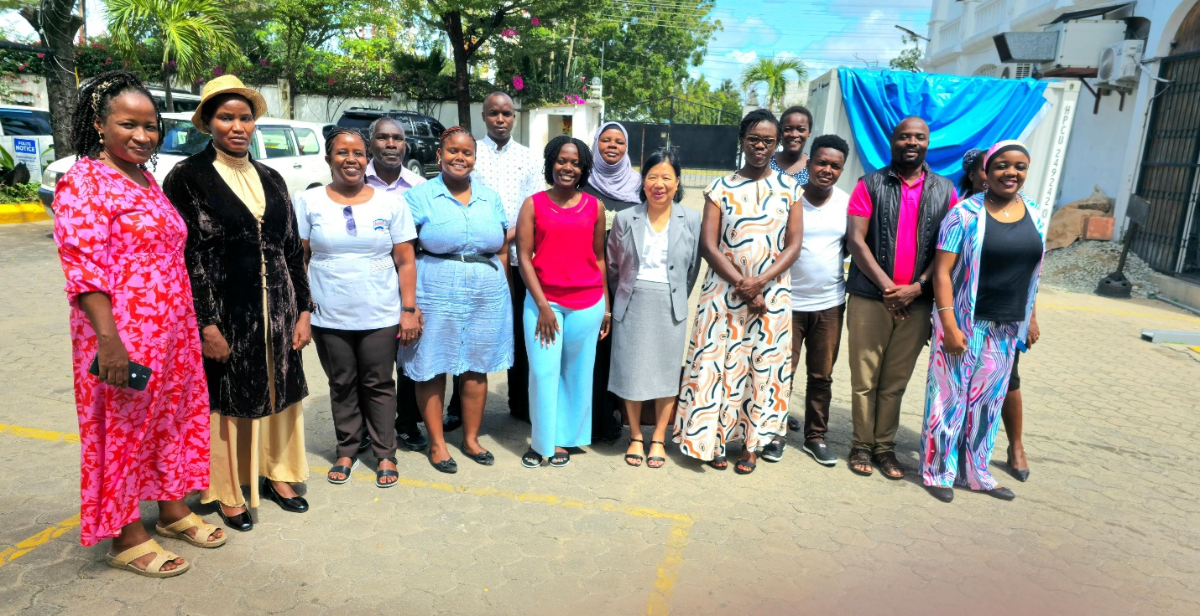
Picture 5: Nairobi Workshop Attendees at Sentrim Royal Castle Hotel

